

Communications Management Process©
For [Project Name]

Document Control

Document Information
© | Information
Document Id | [Document Management System #]
Document Owner | [Owner Name]
Issue Date | [Date]
Last Saved Date | [Date]
File Name | [Name]

Document History
Version | Issue Date | Changes
[1.0] | [Date] | [Section, Page(s) and Text Revised]

Document Approvals
Role | Name© | Signature | Date
Project Sponsor

Project Review Group

Project Manager

Quality Manager
(if applicable)

Procurement Manager
(if applicable)

Communications Manager
(if applicable)

Project Office Manager
(if applicable)

Table of Contents

Template Guide 1
1 Communications Process 2
1.1 Overview 2
1.2 Identify Message 4
1.3 Create Message 5
1.4 Review Message 5
1.5 Communicate Message 5
2 Communications Roles 6
2.1 Communications Team 6
2.2 Communications Manager 6
2.3 Project Manager 6
3 Communications Documents 7
3.1 Communications Register 7
3.2 Project Status Report 7

Template Guide
What is a Communications Management Process?

A Communications Management Process is a method by which formal messages are identified, created, reviewed and communicated within a project. Clear, accurate and timely communication is critical to the success of any project as miscommunication can result in increased project risk. Clear project communication therefore ensures that the correct stakeholders have the right information (at the right time) with which to make well-informed decisions.

Various types of formal communication may be undertaken within a project, including releasing regular project status (or performance) reports, communicating project risks / issues / changes or summarizing project information within weekly newsletters. Regardless of the type of communication to be sent, the method for undertaking the communication will always remain the same. The following procedures are undertaken when formally communicating messages within a project:

- Identify message content, audience, timing and format
- Create message for review
- Review message accuracy and timeliness
- Communicate message to audience. ©

When to use a Communications Management Process

Although the Communications Management Process is typically undertaken after the Communications Plan has been documented (i.e. during the ‘Execution’ phase of the project), communications will take place during all phases of the project. This process therefore applies to all formal communications undertaken during the life of the project, including Project Closure. Without a formal Communications Management Process in place, it will be difficult to ensure that all project communications are undertaken in a formal, structured manner – thereby placing the project at risk. ©

The Communications Management Process is terminated only when the Execution phase of the project is completed and the Project Closure has been communicated to all project stakeholders.

How to use this template
This document provides a guide on the topics usually included in a Communications Management Process. Sections may be added, removed or redefined at your leisure to meet your particular business circumstance. Example tables, diagrams and charts have been added (where suitable) to provide further guidance on how to complete each relevant section.

Communications Process

Overview

Provide an overview of the Communications Management Process. For example:

"The Communications Management Process is undertaken to ensure that project stakeholders are informed of the progress of the project in a timely and accurate fashion."

Communications Management will comprise the following processes:

- Identify Message (content, audience, timing and format)
- Create Message (creation of the actual message to be distributed)
- Review Message (review and approval of the message for distribution)
- Communicate Message (communication / distribution of the message). ©

These four processes will be applied to any type of formal communication on the project, including the distribution of:

- Regular Project Status Reports
- The results of project Stage-Gate Review meetings
- The outcome of all Quality Reviews undertaken
- The minutes of all project team meetings
- Newsletters and other general communication items. ©

The following diagram illustrates the processes and procedures to be undertaken to identify, create, review and communicate key message content within the project. Where applicable, Communications Roles have also been identified:
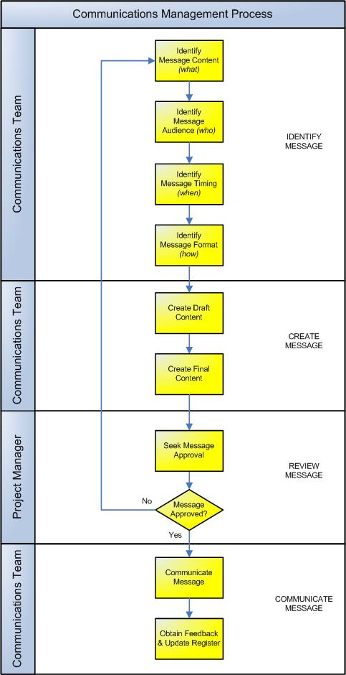

Identify Message
This process involves the identification of the message content, audience, timing and format for approval and distribution to a particular stakeholder group.

Identify Message Content
First, a need for communication is identified. Anyone on the project can identify a communications requirement; however, the Project Manager must be informed of the need and agree that a formal message should be distributed to project stakeholders. The actual message content is then identified and agreed with the Project Manager. Examples of types of message content include:

- The delivery and financial status of the project
- Deliverables produced and milestones achieved
- Supplier performance and procurement status
- Risks, issues and changes identified. ©

Identify Message Audience
A set of key project stakeholders is then identified to receive the message. This forms the ‘message audience’. On large projects it may sometimes be necessary to identify the types of project stakeholders and their requirements for information first, before the message content is identified. Regardless of the order of ‘Identify Message Content’ and ‘Identify Message Audience’, the Project Manager must be comfortable that the audience specified is appropriate to the message being distributed. Examples of particular audience groups include:

- All project stakeholders
- Entire project team
- Project Review Group (or Steering Committee)
- Project Management Team
- Project staff. ©

Identify Message Timing
At this point, the type of content to be distributed and the audience have been clearly specified. The next step is to identify the ‘timing’ or frequency of the communications message. In some cases it may be necessary to have regular communications messages (e.g. weekly Project Status Reports or monthly newsletters), whereas in other cases a one-off communication event may be satisfactory (e.g. notification of a change in project office premise). In all cases, the Project Manager will need to be satisfied that the regularity of the message is suitable, based on the message content and audience.

Identify Message Format
Finally, the format of the message is identified to ensure that the message is communicated accurately and appropriately to the message audience. A number of possible types of message formats may be used, including verbal, report, letter or email.

Create Message
The content of the message is then drafted and the final draft reviewed by the Communications Manager prior to approval.

Create Draft Content
The first draft of the content is created by the Communications Team. The Communications Manager reviews the content and forwards changes to the Communications Team for further enhancements.

Create Final Content
The final draft of the message is then drawn up by the Communications Team and submitted by the Communications Manager to the Project Manager for approval and release.

Review Message
The communications message is then submitted for approval. Depending on the project size and type of message to be distributed, the Project Manager may / may not be empowered to approve the message for distribution. Examples of types of messages that the Project Manager is typically empowered to communicate include:

- Regular project status
- Project risks and issues
- Requests for project changes
- Regular project news items. ©

Certain types of messages, however, may require the Project Review Group's or Sponsor's approval prior to distribution. Examples include communications surrounding:

- Any approved increased scope of the project
- Project critical risks / issues identified
- Major project overspending
- Project Closure.

The Project Manager / other approval body may either:

- Approve the message for distribution
- Delay the message approval by requesting a change to the message
- Decline the message for distribution. ©

Communicate Message
The message is approved and ready to be distributed to the specified target audience.

Communicate Message
The message is formally dispatched to the target audience, using the approved communication method.

Log Message
Once the message has been formally distributed, a communications log (or ‘register’) is updated to record the communications event undertaken. It is also important to receive feedback regarding the message sent to ensure that it achieved the desired results.

Communications Roles

Define the roles and responsibilities for all resources (both internal and external to the project) involved with the identification, creation, review and communication of formal messages within the project. The number and types of communications roles will depend on the size and complexity of the project. For instance, on a small project the Project Manager may fill the role of Communications Manager and the Communications Team responsibilities may be undertaken by a Project Administrator. Regardless of who actually fills each communications role, it is important to identify the generic communications responsibilities required to be undertaken on the project. Examples include:

Communications Team
The Communications Team draw up each communications message and make alterations as requested by the Communications Manager. They are responsible for:

- Formally documenting each communications item
- Making alterations to each communications message as requested
- Publishing the final approved message
- Distributing the published message to the specified audience. ©

Communications Manager
The Communications Manager oversees the Communications Team by reviewing all communications messages prior to approval. This includes:

- Assisting the Project Manager with identifying the content, audience, timing and format
- Reviewing all communications items and recommending final changes
- Submitting the final draft to the Project Manager for approval.

Project Manager
The Project Manager has sole responsibility for ensuring the release of accurate and timely communications messages within the project. This includes:

- Documenting a Communications Plan early in the lifecycle of the project
- Identifying the content, audience, timing and format of communications
- Approving (or arranging the approval of) all communications messages
- Receiving feedback regarding communications messages released. ©

Communications Documents

List any other documentation used to undertake Communications Management within the project.

Communications Register
The ‘Communications Register’ is the log / database where all communications messages are recorded for the project. Insert a template for the Communications Register here to show how communications will be tracked on this project. (NB Refer to the Method123 ‘Communications Register’ for a complete example).

Project Status Report
The ‘Project Status Report’ is used to regularly provide project stakeholders with an understanding of the current status of the project. Insert a template for the Project Status Report here to show how the status of the project will be formally communicated to specified project stakeholders. (NB Refer to the Method123 ‘Project Status Report’ for a complete example).

